Manufacturing of K-Cups

_________________________________________________________________________________________________

Self-Selected Homework

Dylan Channell

MEEG453

November 8, 2017

This report contains a history of K-Cups, detailing the evolution of the product over time. The general manufacturing process will be described, including specific machinery. This is followed by a section on the economic aspects of K-Cup manufacturing, as well as the consumer impact on the product. Next is a discussion on the relevance of the topic for beginning and experienced engineers. The last section discusses the information learned through the project.

History

The K-Cup was created from the need to quickly brew a single cup of coffee at a time. In the mid-1990s, Keurig became the first recognizable brand to offer single serve coffee pods, and as a result, they held the patents for the K-Cup design. However, in 2012, they lost the patents, spawning a manufacturing frenzy amongst competitors. Now any coffee company can make K-Cups specifically for their product. Packaging companies have seized this opportunity to sell K-Cup manufacturing machines. Although individual machines may differ, the basic process is the same.

Manufacturing Process and Equipment:

*Raw materials*

A typical K-Cup coffee pod consists of four components: the aluminum lid, paper filter, polypropylene plastic cup, and ground coffee. Polypropylene and aluminum are used to contain and protect the product. These materials are chosen to limit the risk of puncture during transportation. Additionally, they provide an oxygen barrier for the coffee, lengthening its shelf life before it gets stale. Finally, polypropylene is used for its recyclability. Figure 1 depicts the materials in their respective configuration.

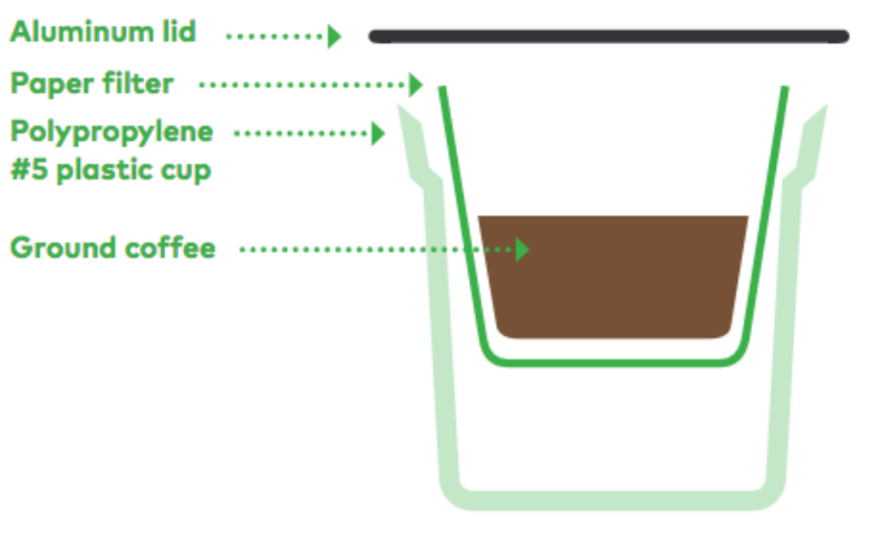

**Figure 1.** Diagram of typical K-Cup.

*Molding Cup*

Coffee companies will generally purchase the plastic cups as opposed to manufacturing them. Up until 2016, K-Cups were made out of a non-biodegradable plastic #7. These cups were molded via a thermoforming process. The new polypropylene cups, on the other hand, are injection molded.

*Filling*

The purpose the filling station is line the cups with a filter and then dispense a predetermined amount of coffee into each one. This process starts by dropping the cups one by one into pucks. A sensor is used to ensure the puck has a cup. The puck moves onto the filter station. Here, a stamp cuts, forms, and places the filter in each cup. A vacuum system suspends the filter in the cup while a heating element seals it to the sides of the container. The filter paper is supplied by a large spool, which spins intermittently in conjunction with the stamping process. A sensor once again monitors the placement of the filter paper. Finally, the unit moves to the coffee filling station. Coffee is dispensed via an auger filler, which simultaneously injects nitrogen into the container to form a modified atmosphere that is resistant to oxidation.

*Sealing*

The puck then moves onto the sealing station. Here the aluminum lids are individually sealed to the cups using another heating element. The K-Cup is then removed from the puck and placed on a conveyer belt where it joins the rest of the bulk product. The entire filling and sealing process is automated except for loading the paper filter into the feeding system, which is done manually.

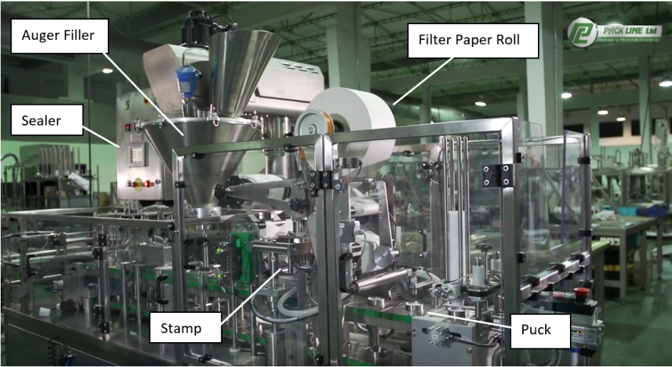

**Figure 2.** Components of the Pack Line filling and sealing stations.

Economics

Single serve coffee pods are an increasingly expanding industry. Keurig’s coffee brand, Green Mountain, sold over 9 billion K-Cups in 2015. Competition is widespread now that their patent expired. Machinery manufacturers are also widespread, taking advantage of the opportunities to sell to aspiring coffee companies, both large and small. One company, Pack Line East, sells two machines which vary based on desired output. Their smaller one has a production rate of 25 to 100 units per minute, while the larger one can do 290 to 320. This allows them to cater to their client’s capital constraints and production rate requirements. In the past years, K-Cups were met with much criticism. Their original plastic container was non-biodegradable, causing customers to consider reusable options. In order to satisfy consumer demands and limit any possible economic hindrance, the cup was redesigned with a recyclable polyethylene casing.

Relevance

The significance of this topic for a beginning engineer is it encapsulates manufacturing equipment and how they interact with one another. The filling and sealing stations combined material handling (pucks and conveyers) with material processing equipment (stamps, augers, and heating elements), all while being monitored with a machine vision system (infrared and ultrasonic sensors). The significance of this topic for an experienced engineer is to realize that machines should be designed to meet their client’s needs. While a certain system may optimize the K-Cup production process, it may be out of the scope for their customer.

Learning

Through this project, I learned the manufacturing processes involved in making K-Cups, the evolution of the market, as well as the consumer’s influence on product design. Although I’ve been a user of K-Cups for years, I never had the opportunity to consider how they were made. I wanted to take my newly acquired manufacturing knowledge and apply it to a product I love. I begin my research with a web search of the process, and found Pack Line East packaging machines. From that I learned the basics steps of the manufacturing process. Realizing that there were an unusually abundant amount of K-Cup machine suppliers, I then performed a search of its history. This brought me to learn that the expiration of the K-Cup patent led to a surge in competition. With these searches, I began to see common articles related to the recyclability of K-Cups. I was then able to draw connections between consumer demands and market response.

References

Humphries, Matthew. “After a Decade of Trying, Keurig Finally Creates K-Cups You Can Recycle.” *Geek.com*, www.geek.com/geek-cetera/after-a-decade-of-trying-keurig-finally-creates-k-cups-you-can-recycle-1652608/.

“K-Cup Single Serve Coffee Packaging.” *Pack Line East*, www.packlineeast.com/k-cup-coffee-single-serve-coffee.

Johnson, Jim. “Keurig Maker Moves Faster than Expected on Recyclable K-Cup Pods.” *Plastics News*, www.plasticsnews.com/article/20170613/NEWS/170619972/keurig-maker-moves-faster-than-expected-on-recyclable-k-cup-pods.